CTS1132 Lab 9.1
Windows Backup
Items needed
- Windows 7 with a user that is a member of the Administrators group and enough unallocated space to backup Windows 7 libraries.
Instructions for K10
- Start Virtual Box and login to CTS1327Win7_01 as Student01.
- From the unallocated space, create a simple volume formatted NTFS.
- Backup the folders for Student01 to the new volume.
- Make sure the Backup will run every Friday at 11PM and take a screen shot of the “Set up backup” window where you set the backup schedule and save as LastnameLab8_1.png.
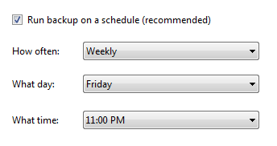
- Close Backup and Restore.
- Browse to Student01’s folders and delete all but the Desktop folder and take a screen shot and save as LastnameLab8_2.png. See below.
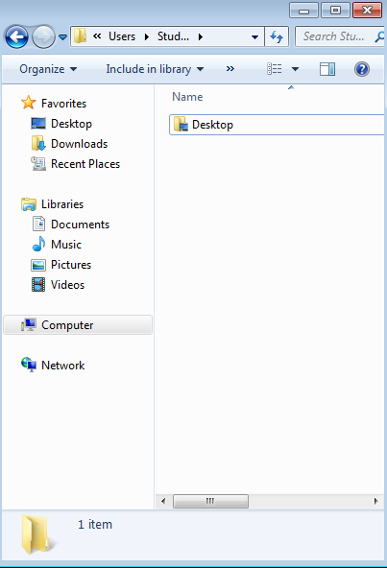
- Restore all of Student01’s folders from backup and take a screenshot and save as LastnameLab8_3.png. See below.
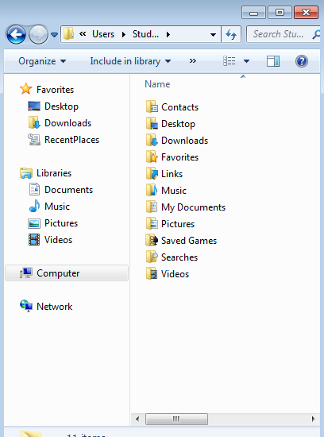
- Upload the screenshots to Angel.

