CTS1132 Lab 5.1: Build a Custom PC
Items needed
- Tool kit with anti-static strap
- Custom PC case
- Custom PC tub
In K-09
- Open the Custom PC tub. Using the Custom PC Checklist, inventory the contents.
- Notify the lab assistant of any missing or damaged contents.
- Have lab assistant initial the Custom PC Checklist.
- Have the lab assistant initial here ________________.
- Review the case manual.
- Review the power supply manual.
- Review the motherboard user’s manual.
- Put the case on the anti-static mat.
- Put on anti-static strap.
- Open case and make sure the standoffs are in the correct location for the motherboard and tighten.
- Install the I/O shield.
- Carefully remove the motherboard out of the anti-static bag being careful to avoid ESD (handle by the edges and don’t touch motherboard components.
- Install the motherboard over the standoffs and snug against the I/O shield.
- Screw down the motherboard snug but DO NOT OVER TIGHTEN.
- Install the power supply.
- Attach the power supply’s motherboard connectors (20+4pin main connector and ATX 4pin connector.
- Make sure the CPU fan is properly connected (manual pg. 14, item 3/4).
- Attach the case fan (manual pg. 14, item 3/4).
- Connect the Front panel header connections, see image below (manual pg. 16, item 8).
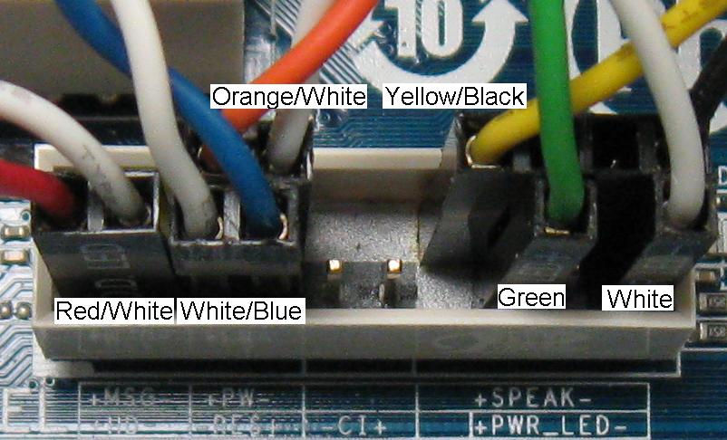
- Connect the Front panel audio header connections (manual pg. 17, item 9).
- Connect the USB header (manual pg. 18, item 12).
- Install SATA HDD. Attach power and data cable.
- Install SATA DVD ROM drive. Attach data cable. Attach molex to SATA adapter to molex power connector and attach power to drive.
- Attach SATA data cables to SATA connectors on motherboard.
- Have lab assistant initial here ________________________.
- Power on the PC and listen for beep code(s).
- Troubleshoot any errors.
- When there are no errors, have lab assistant initial here _____________________.
- Carefully (do not rip cables off) disassemble the PC and return all parts to the Custom PC tub.
- Using the Custom PC Checklist, inventory the contents.
- Notify the lab assistant of any missing or damaged contents.
- Have lab assistant initial the Custom PC Checklist and return the Custom PC tub.
- Put the case together and place under repair station.
- Return the tool kit.
- Have the lab assistant initial here ________________.
- Hand in this sheet to the instructor.

